**CS631008 Data Mgt Systems Design**

**Project Deliverable 1: Analysis and Conceptual Schema**

**Team Members:**

Shiva Karthik Pinjarle Manmohan

Nithin Krishna Krishnappa

Tejas Belakavadi Kemparaju

**1. Goals of this Phase:**

* Understand the requirements of the City Library system thoroughly.
* Develop a conceptual schema that accurately represents the entities, relationships, and constraints of the system.
* Identify any potential issues or ambiguities in the requirements and address them in the schema.

**2. Extended ER Diagram:**

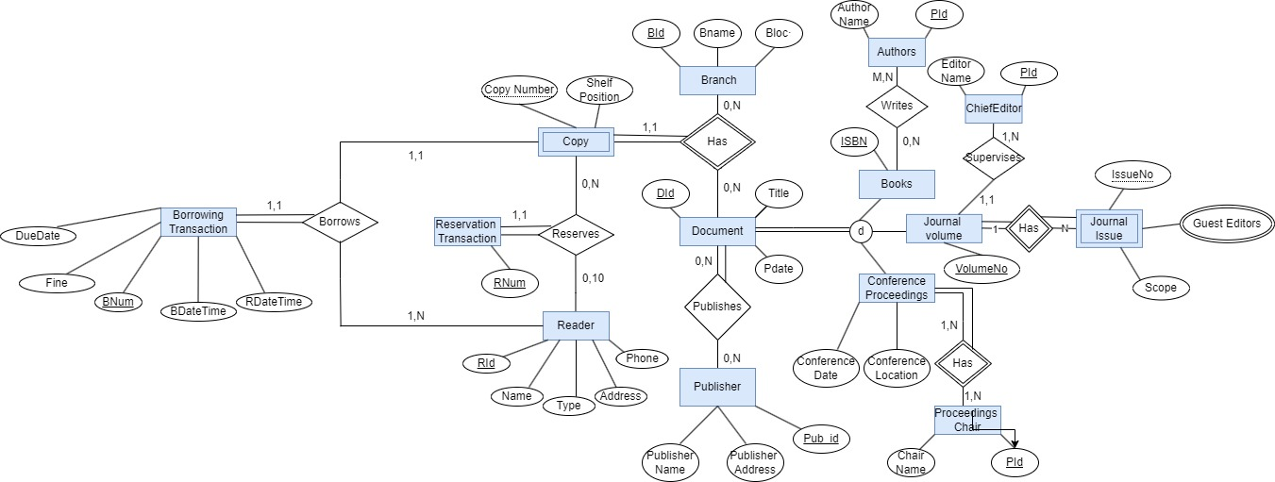

**Entities and Attributes:**

1. Document (DId: PK, title, publication date, type, Number of copies)

The type has subtype attributes that can take on the values 'book', 'journal volume', or 'conference proceedings'

2. Book (DId: FK, ISBN: PK)

3. Journal Volume (DId: FK, volume number: PK)

Has 0 to 10 Journal Issues

4. Journal Issue (volume number: FK, issue number: PK)

issue number uniquely identifies a journal issue within a volume

5. Conference Proceedings (DId: FK, conference date, conference location, PId: FK)

6. Publisher (pub_id: PK, name, address)

7. Person (PId: PK, Pname)

Person is a superclass of Book Author, Editor, and Conference Proceedings Chair

13. Branch (BId: PK, name, location)

14. Copy (DId: FK, BId: FK, copy number, shelf position)

Copy number uniquely identifies a copy of a document at a branch

The total number of copies of each document across all branches is derivable

15. Reader (RId: PK, name, address, phone, type, NumResBooks, NumBorBooks)

Type attributes had subclasses of ("student", "senior citizen", "staff" etc.)

16. Reservation Transaction (RNum: PK, RId: FK, ResStatus, copy number: FK )

Reserves 0 or more Documents for a Reader

Each Reader can have up to 10 active Reservation Transactions

18. Borrowing Transaction (BNum: PK, RId: FK, copy number: FK, datetime borrowed, datetime returned, DueDate, Fine)

Borrows 0 or more Documents for a Reader

Each Reader can have up to 10 active Borrowing Transactions

**Relationships:**

1. Document Publishes Publisher

2. Publisher PUBLISHES 0 or more Documents

3. Book AUTHOR person 1 or more Book Authors

4. Person Author books many to many Books

5. Journal Volume EDITS By Person

6. journal volume has Journal issues

7. Journal Issue HAS GUEST EDITOR in persons

9. Conference Proceedings HAS CHAIR in persons

10. Conference Proceedings Chair CHAIRS 1 or more Conference Proceedings

11. Branch has 0 or More Copies

12. Copy has exactly 1 Branch

13. Copy reserves Reservation Transaction   
14. Copy reserves Readers

14. Reader HAS 0 to N Reservation Transactions

17. Borrowing Transaction Borrows Reader

18. Reader DOES 0 to 10 Borrowing Transactions

**Participation Constraints:**

**Total Participations:**

1. Document (total): This means that every document in the system must have an associated publisher. It is related to the relationship between "Document HAS Publisher".

2. Publisher (total): This indicates that every publisher must have published at least one document. It is related to the relationship "Publisher PUBLISHES 0 or more Documents".

3. Journal Volume (total): Each journal volume must have an editor associated with it. It is related to the relationship "Journal Volume HAS EDITOR 1 Journal Chief Editor".

4. Journal Issue (total): Every journal issue must be part of a journal volume. It is related to the relationship "Journal Issue BELONGS TO Journal Volume".

5. Conference Proceedings (total): Each conference proceeding must have at least one chair. It is related to the relationship "Conference Proceedings HAS CHAIR 1 or more Conference Proceedings Chairs".

7. Journal Chief Editor (total): Each journal volume must have a chief editor. It is related to the relationship "Journal Volume HAS EDITOR 1 Journal Chief Editor".

8. Journal Issue Guest Editor (total): Every journal issue can have zero or more guest editors. It is related to the relationship "Journal Issue HAS GUEST EDITOR 0 or more Journal Issue Guest Editors".

9. Conference Proceedings Chair (total): Each conference proceeding must have at least one chair. It is related to the relationship "Conference Proceedings HAS CHAIR 1 or more Conference Proceedings Chairs".

10. Branch (total): Every branch must exist in the system. It is related to the relationship "Branch HOLDS 0 or more Copies".

11. Copy (total): Each copy must be associated with a branch. It is related to the relationship "Copy IS HELD BY exactly 1 Branch".

12. Reader (total): Every reader must be registered in the system. It is related to various borrowing and reservation transactions in which readers participate.

**Partial Participations:**

1. Book (partial): Not all documents are books, so the participation of books is partial. It is related to the "Book" entity and the "Document" entity.

2. Book Author (partial): Not all books have associated authors, so the participation of book authors is partial. It is related to the "Book Author" entity and the "Book" entity.

3. Reservation Transaction (partial): Not all readers perform reservation transactions, so their participation in reservation transactions is partial. It is related to the "Reservation Transaction" entity and the "Reader" entity.

4. Borrowing Transaction (partial): Not all readers perform borrowing transactions, so their participation in borrowing transactions is partial. It is related to the "Borrowing Transaction" entity and the "Reader" entity.

**Cardinality Constraints:**

1. Document 0:N Publisher

2. Publishers 0:N documents

3. Book 1: M Person, Person M:N books

3. Journal Volume 1:N Journal Issues

5. Conference Proceedings Has chairn in Person

6. Branch 0:N Copy, Copy 1:1 Branch

7. Reservation Transaction 1:N Copy, Copy 0:10 Reservation Transaction

8. Borrowing Transaction 0:N Readers

10. Reader 1:N Borrowing Transaction

**3. Assumptions:**

* Assuming a single library system for the entire city, without subdivision into smaller systems for individual neighborhoods.
* Each document copy has a unique identifier within a branch but is not necessarily globally unique across all branches.
* All readers must be registered in the system before borrowing any documents.
* Readers can only reserve and borrow documents that are available in the library's inventory.

**4. List of Constraints:**

* Each document must have at least one copy available in the library.
* A document can be authored by multiple authors.
* Each borrowing transaction must have at least one document copy associated with it.
* Reserved copies must be picked up before 6 pm on the scheduled day, or the reservation is canceled.
* Readers cannot borrow or reserve more than 10 documents simultaneously.

**5. Difficulties Faced:**

* Balancing the level of detail in the schema with the need for simplicity and clarity.
* Defining the relationships and constraints accurately based on the given requirements.